**Lab report no 2**



**Fall 2022**

# Control System Lab

**Submitted By**

**Name Registration No**

# Muhammad Ali 19pwcse1801

Section: **A**

**Date**: 20,10,22

**Submitted to: Dr Muniba Ashfaq**

Department of Computer Systems Engineering

University of Engineering and Technology, Peshawar

**Objectives: -**

* **To learn how to find impulse response of LTI system MATLAB.**
* **To understand usage of transfer function.**
* **To learn how to pass different input signal to the system.**
* **To practice all of these tasks in Simulink of MATLAB.**
* **And to Compare code and Simulink outputs.**

**Task no 1: -**

**Find impulse response of LTI system using simulink in matlab. For following expression of system 100/x2+4x+20.**

clc

clear all

close all

t=0:0.01:40;

num = [100];

denum =[1 4 20];

sys = tf( num,denum);

**Task no 2: -**

**Pass the sinusiodal signal as input through the system.**

%sinusiodal input

u = sin(t);

y1 = lsim(sys,u ,t);

**Task no 3: -**

**Addition of task1 and task2.**

y2 = step(sys,t);

y3 = step(sys, 5:0.01:40);

temp = zeros(500,1);

y3 =[temp;y3];

y = y1+y2+y3;

**Task no 4: -**

**Square wave with time period 10sec and simulation time 40sec.**

t1 = 0:0.01:40;

ysqr = 2*square(2*pi*0.01*t1);

y_sqr =lsim(sys, ysqr, t1);

**Task no 5: -**

**Add task4 with resultant of task3 and then plot across the time ranged 40sec.**

com = y_sqr + y;

plot(t1,com);

**Final Plot : -**

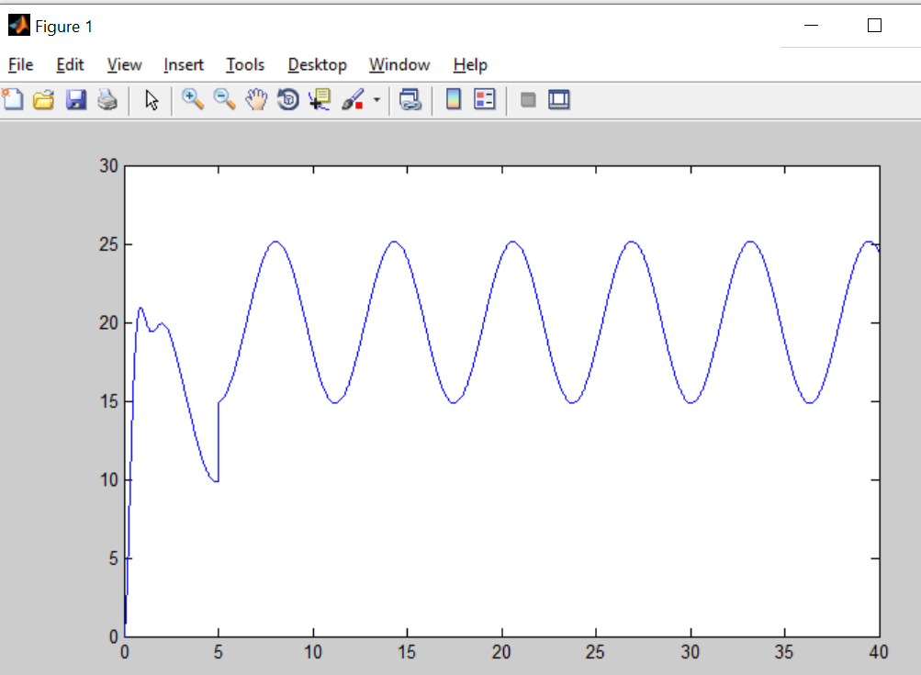

**Simulink design: -**

Same work (all 5 tasks) design by different block components in simulink.

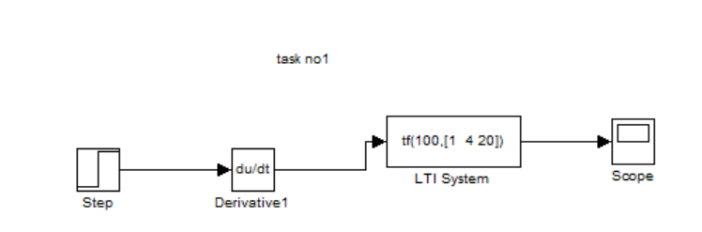

**Task 1 scope output: -**

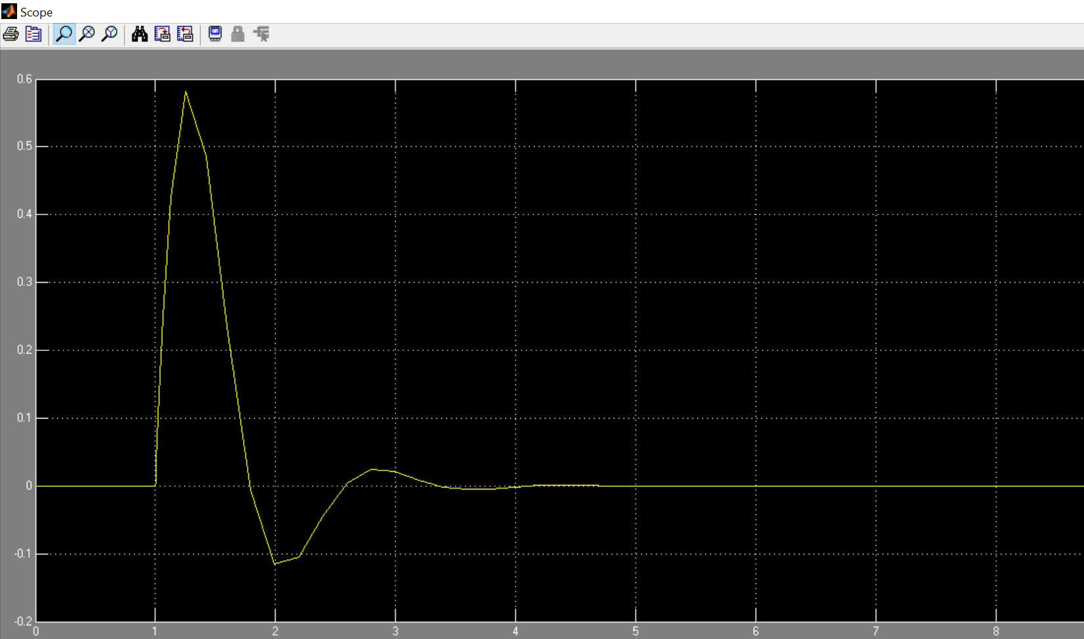

**Simulink design: -**

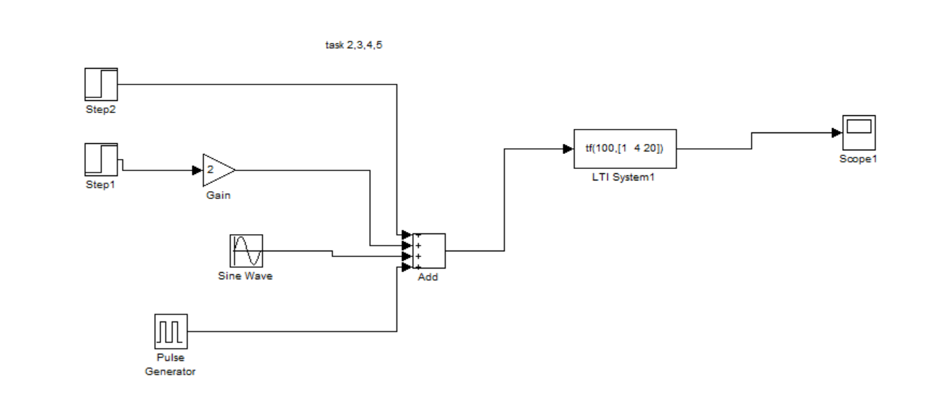

**Final scope output: -**

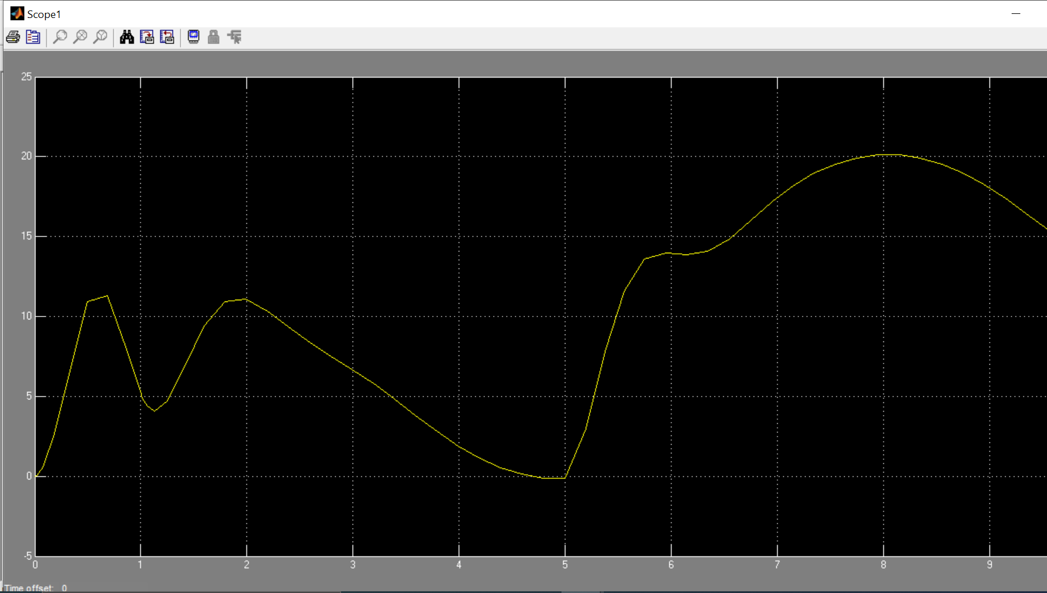

**Comparision: -**

We have seen that both final graphic outputs are same to some extent, but not exactly the same because of some internal delays and others difference of displays view.